
Company
Logotype

Cone Beam Computed Tomography- Report



Porur Dental X-rays & CBCT

Patient Name : Mrs. Lakshmi | Date of Report : 15.10.2025
Age/ Gender : 61 years/ Female | Region of Interest : CBCT Full Skull
Referring doctor: Dr. Selvaganesh | Indication : Implant assessment
Clinical Notes: Nil
PATIENT INFORMATION

CBCT- Full Skull provided
CBCT – IMAGE DETAILS

RADIOGRAPHIC INTERPRETATION

- Complete loss of crown and root structure in relation to 28, 37, 38, 45, 46, 47, 48.
- The alveolar ridge in relation to the maxillary and mandibular alveolar ridge is present with normal trabecular pattern.
- Hyperdense crown structures present in relation to 12, 13, 14, 15, 16, 17, 21, 22, 23, 24, 25, 26, 27, 34, 35, 36.

IMPLANT ASSESSMENT

 | 37 region | 45 region | 46 region | 47 region
Sub-Crestal (in mm) | 5.2 | 4.2 | 3.9 | 4.8
Mid- Crestal (in mm) | 7.1 | 5.4 | 5.6 | 7
Distance between alveolar ridge and the inferior alveolar nerve canal (in mm) | 10.5 | 13.5 | 16.1 | 11.7
Distance between alveolar ridge and the inferior border of mandible (in mm) | 22.5 | 25.5 | 25.6 | 22.6

RADIOGRAPHIC IMPRESSION

- Partially edentulous maxillary and mandibular arch.
- Crown in relation to 12, 13, 14, 15, 16, 17, 21, 22, 23, 24, 25, 26, 27, 34, 35, 36.

Kindly correlate with clinical findings


IMAGES FOR REFERENCE

RECONSTRUCTED PANORAMIC VIEW

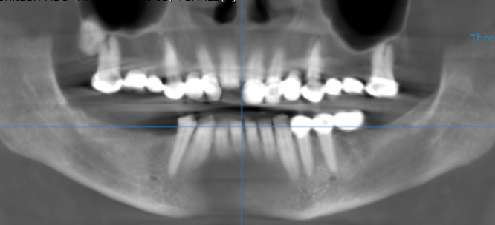

3-DIMENSIONAL VIEW

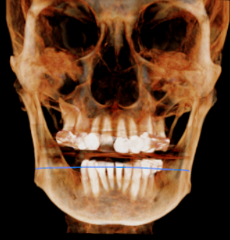

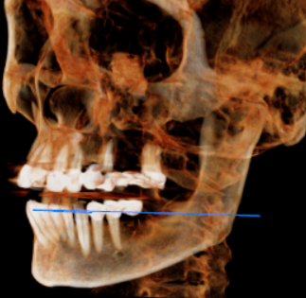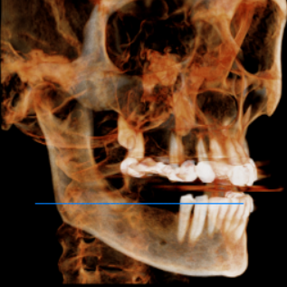

CROSS SECTIONAL VIEW

37 region | 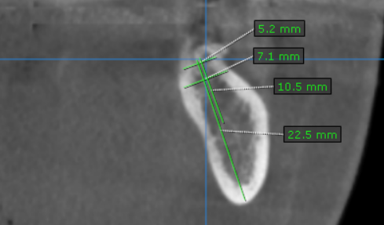
45 region | 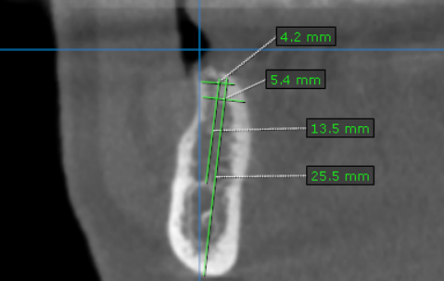
46 region | 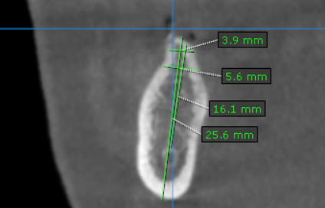
47 region | 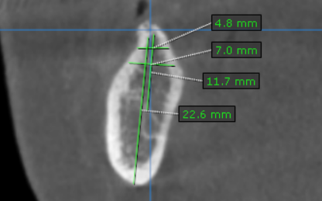

**** End of report ****

